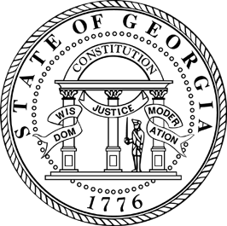
STATE OF GEORGIA

OFFICE OF THE GOVERNOR

Sonny Perdue
GOVERNOR

For Immediate Release Contact: Office of Communications (404) 651-7774
Friday, December 14, 2007 Jennifer Rippner, OSA, (404) 651-7792

Governor Perdue Announces
Water Conservation Contest Winners
Contest winners designed conservation plans to be used in their communities

ATLANTA— Governor Sonny Perdue announced today the winners of the Governor’s Water Conservation Contest: Fayetteville Intermediate School in Fayetteville and River Eves Elementary School in Roswell. The Governor’s Water Conservation Contest asked students in 3rd, 4th and 5th grades to develop a water conservation plan for their community. The contest was designed to encourage students to think creatively of ways to preserve water by designing a plan that promotes water conservation.
“I am proud of all the hard work our young people, with the aid of their teachers and families, have put forth in order to help Georgia in its conservation efforts,” said Governor Sonny Perdue. “Our kids give us proof that we all can come together to find innovative ways to conserve Georgia’s water resources.”
The two schools will receive a $2,000 prize presented by contest sponsor, The Home Depot, to be used to carry out the conservation plan in the community. The individual plans chosen as the contest winners demonstrate unique ways for communities to conserve water while spending less than $2,000.
Governor Perdue gathered a panel of judges to review 85 entries representing over 2,500 students across Georgia. Students came up with a conservation plan and described their proposed project in a detailed essay that included an implementation budget. Each school’s principal chose one winner to submit Governor Perdue for consideration.
The following is a list of the twelve finalists chosen for the Governor’s Water Conservation Contest:

Brookstone School, Columbus
Craig Elementary School, Lawrenceville
Fayetteville Intermediate School, Fayetteville
Lake Windward Elementary, Alpharetta
Lockheed Elementary, Marietta
M.H. Mason Jr. Elementary, Duluth
Mountain Park Elementary, Roswell
River Eves Elementary, Roswell
Warren T. Jackson Elementary, Atlanta
Wesleyan School, Norcross
West Town Elementary, Albany
Whitesville Road Elementary, LaGrange

###

